**SQL QUERY SOLUTION**

Formatting order_date and order_time column to DATE and TIME format

UPDATE pizzadb

SET order_time = str_to_date(order_time, '%H:%i:%s');

ALTER TABLE pizzadb

MODIFY COLUMN order_time TIME;

UPDATE pizzadb

SET order_date = str_to_date(order_date, '%d-%m-%Y');

ALTER TABLE pizzadb

MODIFY COLUMN order_date DATE;

**KPI’S REQUIREMENT**

1. Total Revenue

SELECT SUM(total_price) AS total_revenue

FROM pizzadb;

1. Average Order Value

SELECT SUM(total_price) / COUNT(DISTINCT order_id)

AS average_order_value

FROM pizzadb;

1. Total Pizzas Sold

SELECT SUM(quantity) AS total_pizzas_sold FROM pizzadb;

1. Total Orders

SELECT count(DISTINCT order_id) FROM pizzadb;

1. Average Pizzas Per Order

SELECT SUM(quantity) / COUNT(DISTINCT order_id)

AS average_pizzas_per_order

FROM pizzadb;

CHARTS REQUIREMENT

1. Daily Trend for Total Orders

SELECT DAYNAME(order_date), COUNT(distinct order_id)

FROM pizzadb

GROUP BY DAYNAME(order_date) ;

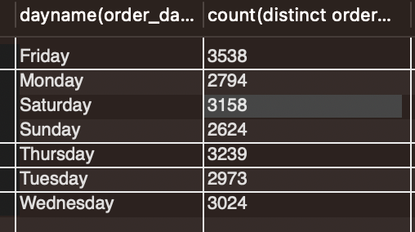

1. Hourly trend for Total Orders

SELECT HOUR(order_time), COUNT(DISTINCT order_id)

FROM pizzadb

GROUP BY HOUR(order_time)

ORDER BY HOURorder_time) ;

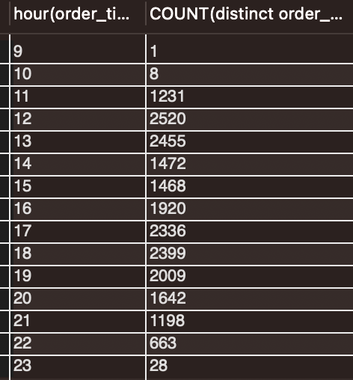

1. Percentage of Sales by Pizza Category

SELECT pizza_category, SUM(total_price) * 100/ (SELECT SUM(total_price) from pizzadb) AS

percentage_of_sales_pizza_category

FROM pizzadb

GROUP BY pizza_category;

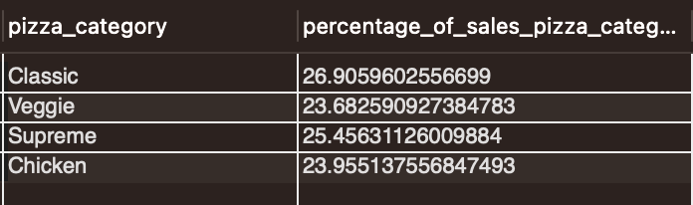

1. Percentage of Sales by Pizza Size

SELECT pizza_size,

CAST(

SUM(total_price) * 100/ (SELECT SUM(total_price) FROM pizzadb) AS DECIMAL (10,2)

)

AS

percentage_of_sales_pizza_size

FROM pizzadb

GROUP BY pizza_size;

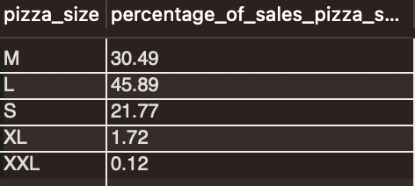

**To get the output per quarter**

SELECT pizza_size, CAST(SUM(total_price) * 100/ (SELECT SUM(total_price) FROM pizzadb WHERE QUARTER (order_date) = 1 ) AS DECIMAL (10,2)) AS

percentage_of_sales_pizza_size

FROM pizzadb

WHERE QUARTER(order_date) = 1

GROUP BY pizza_size;

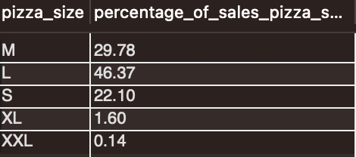

1. Total Pizzas Sold by Pizza Category

SELECT pizza_category, SUM(quantity) AS total_pizza_sold_pc

FROM pizzadb

GROUP BY pizza_category;

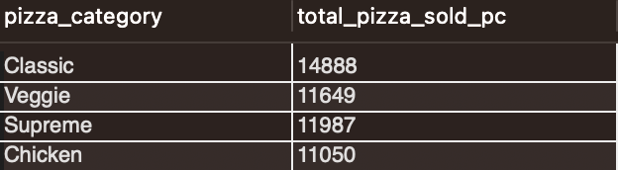

1. Top 5 Best Sellers by Total Pizzas Sold

SELECT pizza_name, SUM(quantity)

FROM pizzadb

GROUP BY pizza_name

ORDER BY SUM(quantity) DESC

LIMIT 5;

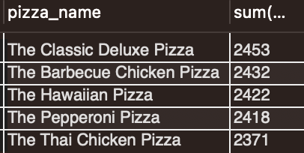

1. Bottom 5 Worst Sellers by Total Pizzas Sold

SELECT pizza_name, SUM(quantity)

FROM pizzadb

GROUP BY pizza_name

ORDER BY SUM(quantity) ASC

LIMIT 5;

